LABORATORY WORK #2

“SECURING LINUX SERVER WITH THE PACKET FILTER IPTABLES”

Lab consists of the following steps:

1. Preparing your own networking server in virtual computer (setting up IP and MAC addresses, checking http, ftp and telnet connections between your Windows and Linux like in the lab #1).
2. Learning information about setting up rules for iptables in Linux.
3. Setting prohibiting policy for networking traffic (disabling all traffic which is not evidently permitted).
4. Creating and testing rules for allowing http, ftp and telnet traffic to your Linux server.
5. Creating and testing rules for allowing pinging your Linux from other Linux servers, but disabling pinging from Windows.

Theoretical part

Packet filters analyze each incoming or outgoing IP-packet (its source and destination IP addresses, port numbers for TCP or UDP protocols, etc.) to compliance with the administrator’s rules. If the IP packet is allowed by these rules, it is processed; otherwise such IP packet is destroyed by packet filter.

As an example of creating such rules, for the following network (fig.1) we need to allow outgoing and incoming smtp traffic (port #25).

PC
91.7.7.1
PC
91.7.7.2
PC
91.7.7.3
PC
91.7.7.50
SMTP
POP3
91.7.7.100
packet
filter
External
network

Fig.1 – an example of the network for setting up rules for the packet filter

Set of rules is given at the table 1 (there is an assumption that all packet which are not explicitly allowed will be blocked by the packet filter).

Table 1 – set of filtering rules for the example network
# | IP_{src} | IP_{dst} | proto | P_{src} (for TCP/UDP ) | P_{dst} (for TCP/UDP ) | Rule | Comment
1 | 91.7.7.100 | 0.0.0.0/0 | tcp | 1024:65535 | 25 | ACCEPT | Outgoing IP-packets for tcp connection of outgoing e-mail
 | 0.0.0.0/0 | 91.7.7.100 | tcp | 25 | 1024:65535 | ACCEPT | Incoming IP-packets for tcp connection of outgoing e-mail
2 | 0.0.0.0/0 | 91.7.7.100 | tcp | 1024:65535 | 25 | ACCEPT | Incoming IP-packets for tcp connection of incoming e-mail
 | 91.7.7.100 | 0.0.0.0/0 | tcp | 25 | 1024:65535 | ACCEPT | Outgoing IP-packets for tcp connection of incoming e-mail
3 | 91.7.7.100 | 8.8.8.8 | udp | 1024:65535 | 53 | ACCEPT | Outgoing IP-packets containing udp packets with the DNS request
 | 8.8.8.8 | 91.7.7.100 | udp | 53 | 1024:65535 | ACCEPT | Incoming IP-packets containing udp packets with the DNS reply

(Do not use this example for real networks; these set of rules is not sufficient, it must be appended with additional rules; otherwise it may have a hidden vulnerability).

Such filtering tables in iptables are called chains.

There are 3 types of built-in chains in iptables: INPUT, OUTPUT, FORWARD (see fig.2). Note, that in the current lab we have only one Ethernet interface (eth0).

LAN-0
Application 1
Application 2
Application N
Linux OS kernel
network interface
eth0
network interface
eth1
INPUT
OUTPUT
FORWARD
iptables packet filter
LAN-1
Linux OS
Fig.2 – iptables filtering chains in Linux

As it can be seen from fig.2, all IP packets generated on Linux computer will be filtered via OUTPUT chain. All IP packets sent to this Linux computer will be filtered via INPUT chain.
All IP packets going from one network to another (Linux is a router) will be filtered by FORWARD chain.

Your task on this lab is to create rules for INPUT and OUTPUT chains for allowing specific type of traffic and disable all other.

1. Preparing your own networking server in virtual computer

Start the program “VMWare player”, and open there the virtual computer “Linux-BIT” (c:\Linux-BIT), start Linux operating system inside it.

“VMWare player” emulates physical computer. Having one PC running Windows XP, you can use two computers with different operating systems at the same time.

To switch to Linux inside VMWare just use a mouse click on VMWare window , for returning to Windows XP – press CTRL+ALT.

Log on inside Linux:
login name: root
password: 1

It should me mentioned, that you won’t see your password symbols (they’re not typed on the screen).
After logging in you should see the following (fig.3):

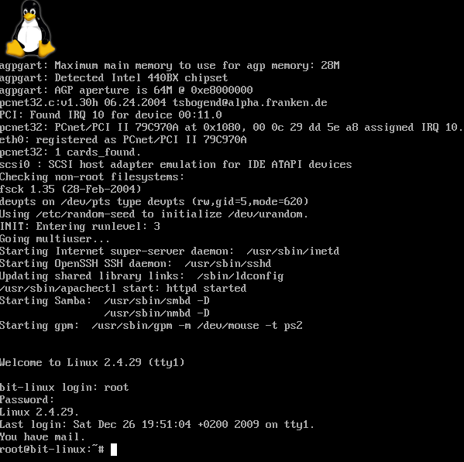
Fig.3 – your networking Linux server after logon

Now you need to set up your network parameters (IP address and MAC address) for Linux.

Find out IP address of your Windows XP computer. Open Windows command line (Start->Run->cmd.exe), and type ipconfig in the windows command line. You should see something like following (fig.4):

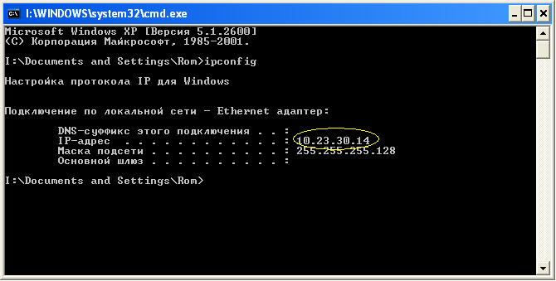
Fig.4 – Windows command line with IP address of your Windows XP

According to this window, IP address of current computer is 10.23.30.14. Your address is different, so, be attentive!
You need to calculate IP address for your Linux computer: take the last number of your IP (14 in this example) and add 70 to that number: 14+70 = 84. So, Linux IP address for this example is 10.23.30.84.

Calculate IP address for your Linux server.

Choose random value for MAC address for your Linux of the following form: 00:0x:xx:xx:xx:xx, where x – is hexadecimal digit (from ‘0’ to ‘9’ and from ‘A’ to ‘F’).
For example, let it be 00:01:23:45:ab:cd

Be attentive, your Linux server or Windows XP workstation with incorrect addresses won’t work, moreover, there could be problems with other computers’ networking.

Next step is setting up IP address and MAC addresses in your Linux:

Switch to Linux (mouse click on VMWare window) and type the following commands (substitute with your own IP and MAC addresses):

ifconfig eth0 down
ifconfig eth0 hw ether 00:01:23:45:ab:cd
ifconfig eth0 10.23.30.84 up
ifconfig

You should see something like following (fig.5):

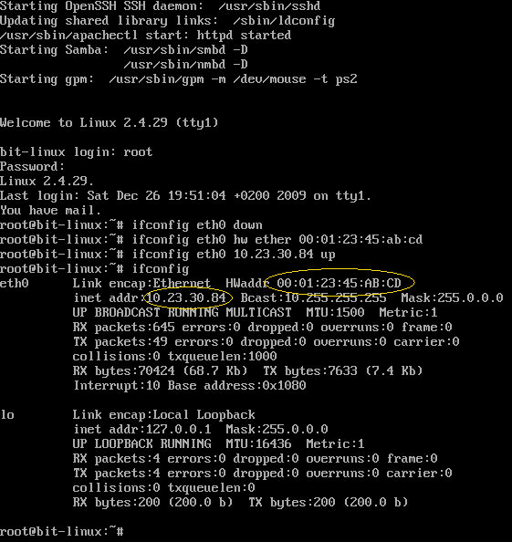
Fig.5 – Linux after setting up your MAC and IP addresses (addresses should be different)

On the next step, check connection between your Windows and Linux computer.

First, ping your Linux from the Windows command line (fig.6):

ping 10.23.30.84

(substitute with your IP of your own Linux).

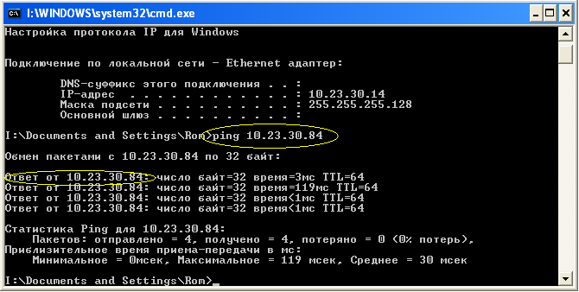
Fig.6 – pinging Linux from the Windows command line (addresses should be different)

After that, check other protocols (telnet, ftp and http).

For telnet in the windows command line type

telnet 10.23.30.84

(substitute with your IP of your own Linux).

Than login as ‘user’ with password ‘1’, after that finish telnet session (‘exit’).

login name: user
password: 1
exit

You should see something like following (fig.7, fig 8):

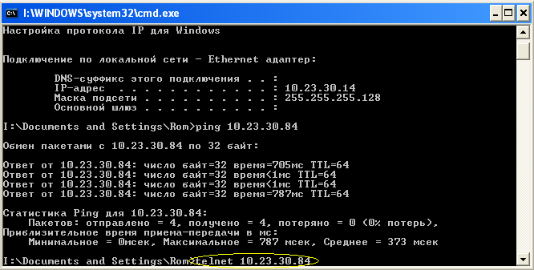
Fig.7 – telnet session from Windows command line to Linux (addresses should be different)

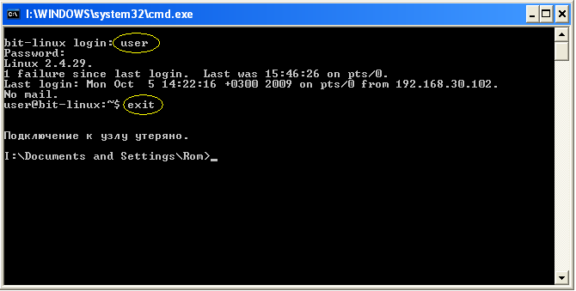
Fig.8 – telnet session from Windows command line to Linux

For checking ftp connection with your Linux server type the following in the windows command line (there can be some delay after typing command and appearance of the server’s reply):

ftp 10.23.30.84

(substitute with your IP of your own Linux).

Then login as ‘user’ with password ‘1’, after that finish ftp session (‘quit’).

user name: user
password: 1
exit

You should see something like following (fig.9):

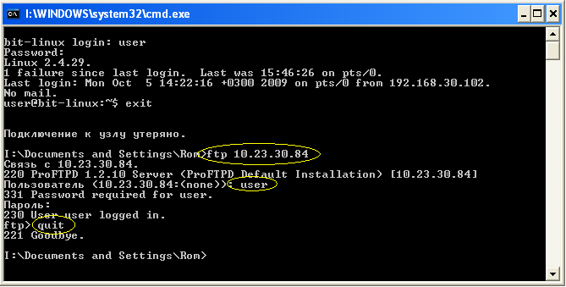
Fig.9 – ftp session from Windows command line to Linux (addresses should be different)

For checking http connection with your Linux server run browser in Windows XP (it can be Internet Explorer, Mozilla Firefox or other) and type IP address of your Linux server in the browser’s address line:

http://10.23.30.84

(substitute with your IP of your own Linux).

You should see something like following (fig.10):

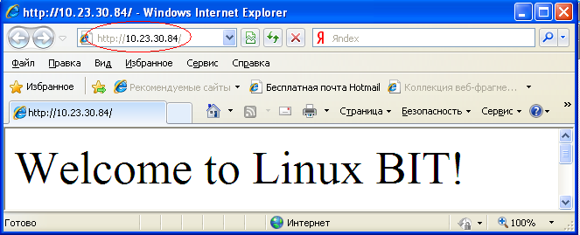
Fig.10 – Web browsing of your Linux server (address should be different)

Now you have finished setting up your networking Linux server.
2. Learning information about setting up rules for iptables in Linux.

In the Linux command line type ‘reset’ command to prepare command line for viewing manual (help) pages:

reset

After preparing terminal, type ‘man iptables’ to view manual page on this utility.

man iptables

You should see manual page (fig.11).

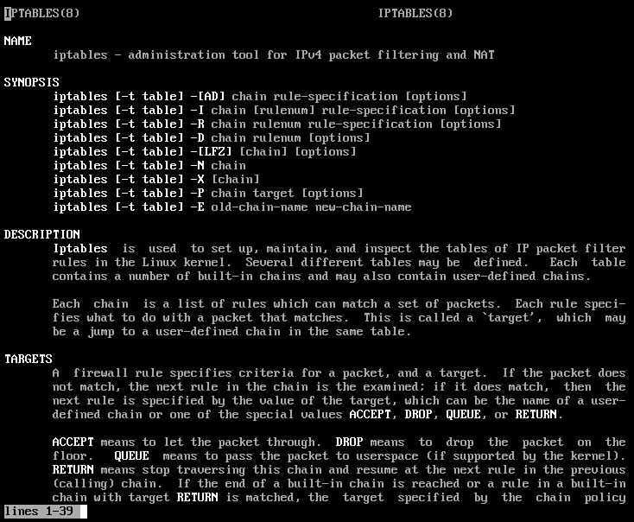
Fig.11 – manual page of iptables

To navigate within the manual page, use arrow (↑ ↓) keys (up and down), PageUp and PageDown keys.
To find the first occurrence of some specific word in the manual page press the slash ( / ) key, type the word to find and press enter. To find next occurrences of this word press a key with the letter n (means “next”).

Look through the iptables manual page. Take your attention to INPUT and OUTPUT chains, selection of IP addresses, selection of protocols (e.g., tcp, udp and icmp) and port numbers (for tcp and udp).

To leave the manual page press a key with the letter q (means “quit”).

You can switch to another consoles (another independent command lines) in Linux by pressing Alt-F2, Alt-F3 and so on (you’ll also need to log on as root on other consoles to use them). To return to the first console press Alt-F1.

It is convenient to read manual page in one console and type commands in other console.

Linux, like all other UNIX-like operating system, is a case-sensitive. So, reset, Reset, reSet, etc. are different commands for Linux.
Similar, parameters for iptables are case-sensitive. For example, “-P” means “policy” and “-p” means “protocol” (for detailed description see manual page).
Be attentive!

3. Setting prohibiting policy for networking traffic.

View your current rules and iptables policy by typing

iptables –L -n

As you have read in the manual page, -L means listing of rules, -n means numerical format (typing without converting IP addresses to domain names, its greatly improves speed of rule displaying).

You should see default rules (fig.12) with allowing policy without any specific rules. It means that all traffic is allowed.

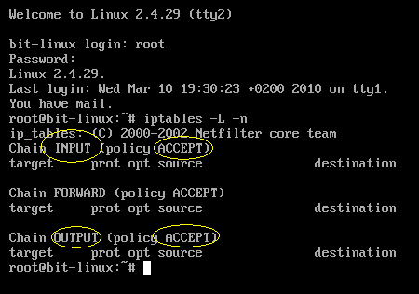
Fig.12 – default policy and rules of iptables

Change default policy to prohibiting. To do it, type

iptables –P INPUT DROP
iptables –P OUTPUT DROP

and check your new policy (like in previous example, “iptables -L -n”). You should see prohibiting policy (fig.13). It means that all traffic is prohibited and no network activity on this Linux system is possible.
Check this by trying to access your Linux system from Windows by pinging, trying to browse and trying to establish telnet or ftp connection.

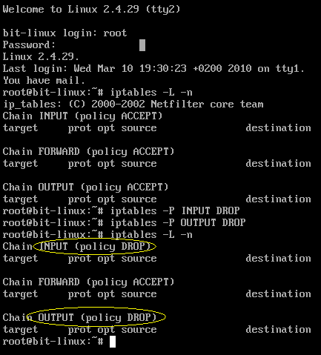
Fig.13 – new prohibiting policy of iptables

4. Creating and testing rules for allowing http, ftp and telnet traffic to your Linux server.

After setting up prohibiting policy, you need to add rules for enabling specific traffic (for allowing http, ftp and telnet access).

To add a rule, iptables command should have the following form:
iptables –A INPUT ………. –j ACCEPT

“-A INPUT” means adding (-A) a new rule to the INPUT chain. You can also use OUTPUT for adding a rule to the correspondent chain.
“-j ACCEPT” (be attentive to the case of letters) means that this is an enabling rule. If you want to create prohibiting rule, use “DROP” or “DENY” instead of “ACCEPT”.

Between “-A INPUT” and “-j ACCEPT” there should be specification of source and destination IP addresses, selection of the protocol, specification of source and destination port numbers. If you want to select some range of port numbers, use colon (“:”).
For exact specification of these parameters, read the manual page.

You need to enable http, ftp and telnet access from your Windows computer to your Linux server.

Add the enabling rule for http to the INPUT chain and check it by listing current rules.

Add correspondent rule for http to the OUTPUT chain and list rules.
If everything looks OK (for your opinion), then run browser in Windows and try to get http access to your Linux system.
If you have added correct rules, then you will see a web page. Otherwise your rules are incorrect and should be changed.

To delete a rule, use “-D” parameter (iptables –D INPUT …). To clear all your rules, use “-F” parameter.
For detailed information, look at the manual page for iptables.

Task is completed when you have prohibiting default policy, but can get access from Windows to your Linux via http, ftp and telnet.

5. Creating and testing rules for allowing pinging your Linux from other Linux servers, but disabling pinging from Windows.

After enabling base protocols (http, ftp and telnet), add additional rule for enabling pinging your computer, but only from Linux computer all over network.

To enable ping, you need to enable icmp protocol.
To find a difference between Windows and Linux IP packets, try to look at TTL field.

After adding that rule to your INPUT and OUTPUT chains, your Windows won’t be able to ping your Linux, but other Linux computers will be able to ping your Linux IP address.

